8-Puzzle Problem
Aim
To develop a Python program that solves the 8-Puzzle Problem using a search algorithm by finding a path from the initial state to the goal state.
Objective
- To understand the concept of state-space search.
- To solve the 8-puzzle using a search algorithm.
- To reach the goal state with valid tile movements.
- To display the solution path.
Algorithm
- Define the initial state and goal state.
- Find the position of the blank tile (0).
- Generate all possible moves (Up, Down, Left, Right).
- Check whether each move is valid.
- Continue searching until the goal state is reached.
- Display the solution.

Flow Chart:
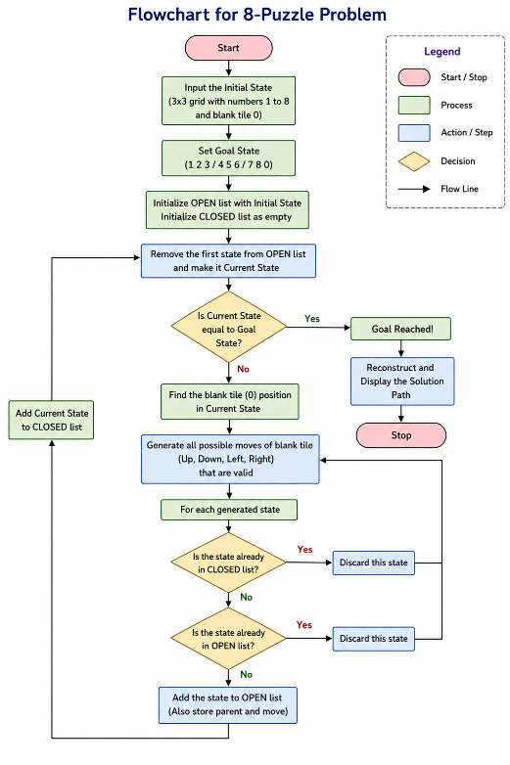

Python Code
from collections import deque

goal = [[1,2,3],
[4,5,6],
[7,8,0]]

start = [[1,2,3],
[4,0,6],
[7,5,8]]

def is_goal(state):
return state == goal

def find_blank(state):
for i in range(3):
for j in range(3):
if state[i][j] == 0:
return i, j

def moves(state):
x, y = find_blank(state)
directions = [(-1,0),(1,0),(0,-1),(0,1)]
result = []

for dx, dy in directions:
nx, ny = x+dx, y+dy
if 0 <= nx < 3 and 0 <= ny < 3:
new = [row[:] for row in state]
new[x][y], new[nx][ny] = new[nx][ny], new[x][y]
result.append(new)

return result

queue = deque([start])
visited = []

while queue:
current = queue.popleft()

if current in visited:
continue

visited.append(current)

if is_goal(current):
print("Goal State Reached")
for row in current:
print(row)
break

for m in moves(current):
queue.append(m)
Sample Output
Goal State Reached
[1, 2, 3]
[4, 5, 6]
[7, 8, 0]
RESULT
